Year 11 Human Biology –

**Inheritance, Variation and Mutations** /45

Name:________________________

**PART A: MULTIPLE CHOICE**

1. To display recessive characteristics you must have:
2. Have both alleles recessive.
3. Have both alleles dominant.
4. One recessive allele and one dominant allele.
5. Physical characteristics due to the genotype.
6. Choose the **incorrect** statement regarding the chromosomes.
   1. Human beings have 46 chromosomes in a normal body cell.
   2. One pair of chromosomes control the formation of asexual characteristics.
   3. In humans there are two types of sex chromosomes.
   4. The 23rd pair of chromosomes are the sex chromosomes.
7. Choose the **incorrect** statement regarding mitochondrial DNA:
   1. It is found only in the ova.
   2. It is inherited from the mother.
   3. It is inherited from the father.
   4. It is located in the mitochondria.
8. Choose the **incorrect** statement regarding sex chromosomes.
   1. The X chromosome is much bigger than the Y chromosome.
   2. Some genes found on the X chromosome are not found on the Y chromosome.
   3. A female has only one copy of all the genes on the X chromosome.
   4. A male has only one copy of certain genes on the X chromosome.
9. Which of the following is **incorrect** regarging a person with Rh antibodies:
   1. Is said to be Rh positive.
   2. Can produce anti-Rh antibody.
   3. Is said to be Rh negative.
   4. Can not produce Rh antigens.
10. [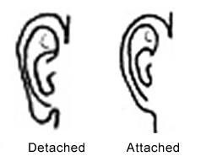](http://www.google.com.au/url?sa=i&rct=j&q=attached+earlobes&source=images&cd=&cad=rja&docid=K3WiVZOA-SbihM&tbnid=TEaxEnH-z2NCyM:&ved=0CAUQjRw&url=http://korrektivpress.com/2005/10/attached-earlobes-and-criminal-tendencies/&ei=Zc9gUuywI8XLkAWm14HICg&psig=AFQjCNE8w_9ybI7WN0exHg1E5NHikqOjYA&ust=1382162655489794)Consider the following information

Mark has detached or free earlobes as does his wife Nicole. Two of their four children have attached earlobes, the other two have detached.

Which of the following statements is **incorrect**?

1. Mark and Nicole are heterozygous
2. The probability of any further children having attached earlobes is 1 in 2 or 50%
3. Attached earlobes is a recessive trait
4. The genotype of the children with detached earlobes can not be determined with certainty

7. Sickle–cell anaemia has a co-dominant pattern of inheritance. This means that if a homozygous male with sickle-cell anaemia and a homozygous female without sickle-cell anaemia have children:

1. The probability of any of their children having sickle-cell anaemia is 50%
2. Half of each of their offspring’s red blood cells will be sickle-cell shaped
3. All of their children will have the sickle-cell trait
4. They will not be able to have children as sickle-cell anaemia is fatal.

8. A particular condition can **not** be recessive sex linked if:

1. A carrier mother and a carrier father have a child with the condition
2. A father with the condition and a homozygous dominant mother have a son with the condition
3. All of the children, both male and female, exhibit the condition
4. A mother and father with the condition have children with the condition

9. Phenylketonuria or PKU is an example of

1. A chromosomal disorder
2. An autosomal dominant condition
3. A sex linked condition
4. An autosomal recessive condition

**PART B: SHORT ANSWER**

1a.John has AB type blood, his wife June has O type blood. Their three children all have B type blood. Explain using punett squares how this is possible. (2 marks)

1b. If John had a car accident who in the family would be able to donate blood to him and why?

(2 marks)

2a. Cystic fibrosis is a recessive autosomal trait. A homozygous male (who has had a lung transplant to treat his cyctic fibrosis) is crossed with a healthy homozygous female. What are the possible offspring? Show full working out and include genotypes, phenotypes and percentages.

(3 marks)

3. Explain the difference between a somatic and germline mutation and point out the implications (effects) of those differences (2 marks)

_______________________________________________________________________________________

_______________________________________________________________________________________

_______________________________________________________________________________________

4. **Explain** the main difference between gene mutations and chromosomal mutations. (2 marks)

_______________________________________________________________________________________

_______________________________________________________________________________________

_______________________________________________________________________________________

5. **List** two examples of conditions caused by gene mutations. (2 marks)

_______________________________________________________________________________________

_______________________________________________________________________________________

6. Name the process shown below: (1 mark)

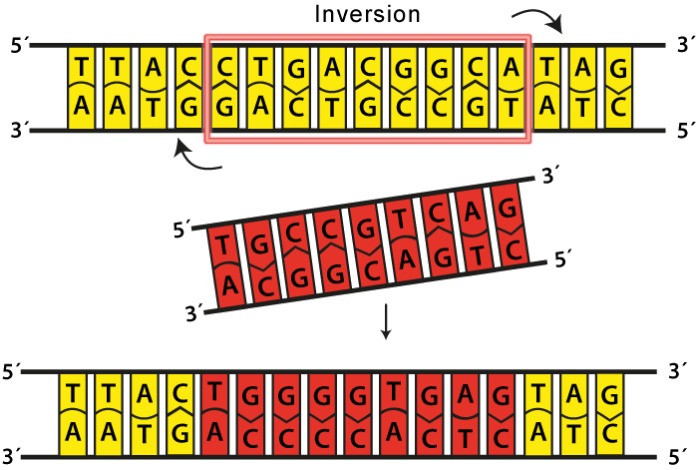

7. On the diagram of meiosis on the next page, show the possible times at which the mutation causing Downs Syndrome may occur. (1 mark)

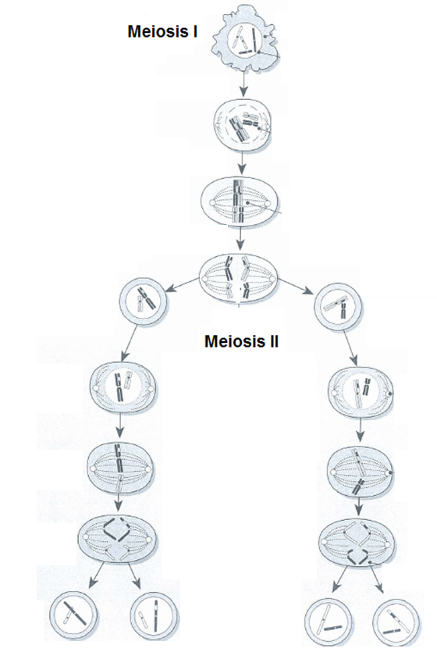

8. Write a definition for the term ‘mutation. (2 marks)

_______________________________________________________________________________________

_______________________________________________________________________________________

_______________________________________________________________________________________

9. For each main group below, give a specific example of a mutagen. (4 marks)

Ionising radiation: ___________________________________________

Diet: ___________________________________________

Pathogens: ___________________________________________

Poisons and irritants: ___________________________________________

10. a. What name is given to the information shown in the diagram below? (1 mark)

_____________________________________________________

b. **State** the sex of the individual shown below. (1 mark)

_____________________________________________________ 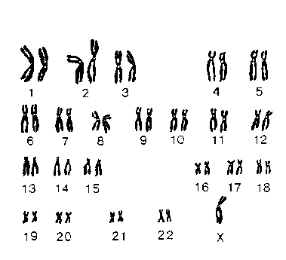

c. **State** whether the individual has monosomy or trisomy. **Explain** your answer. (2 marks)

_______________________________________________________________________________________

_______________________________________________________________________________________

_______________________________________________________________________________________

d. **State** the name of the specific mutation that this individual suffers from. (1 mark)

_____________________________________________________

**PART C: EXTENDED ANSWER**

16)Variation in the human species occurs due to chromosome variation. There are three sources of variation that may occur during meiosis. For each source state when it occurs and describe how it occurs. (9 marks)

_______________________________________________________________________________________

_______________________________________________________________________________________

_______________________________________________________________________________________

_______________________________________________________________________________________

_______________________________________________________________________________________

_______________________________________________________________________________________

_______________________________________________________________________________________

_______________________________________________________________________________________

_______________________________________________________________________________________

_______________________________________________________________________________________

_______________________________________________________________________________________

_______________________________________________________________________________________

_______________________________________________________________________________________

_______________________________________________________________________________________

_______________________________________________________________________________________

_______________________________________________________________________________________

_______________________________________________________________________________________

_______________________________________________________________________________________

_______________________________________________________________________________________

_______________________________________________________________________________________

_______________________________________________________________________________________

_______________________________________________________________________________________

_______________________________________________________________________________________

_______________________________________________________________________________________

_______________________________________________________________________________________

_______________________________________________________________________________________

_______________________________________________________________________________________

_______________________________________________________________________________________

_______________________________________________________________________________________

_______________________________________________________________________________________

_______________________________________________________________________________________

_______________________________________________________________________________________

_______________________________________________________________________________________

_______________________________________________________________________________________

_______________________________________________________________________________________

_______________________________________________________________________________________

_______________________________________________________________________________________

_______________________________________________________________________________________

_______________________________________________________________________________________

_______________________________________________________________________________________

_______________________________________________________________________________________

_______________________________________________________________________________________

_______________________________________________________________________________________

_______________________________________________________________________________________

_______________________________________________________________________________________

_______________________________________________________________________________________

_______________________________________________________________________________________

_______________________________________________________________________________________

_______________________________________________________________________________________

_______________________________________________________________________________________

Year 11 Human Biology –

**Inheritance, Variation and Mutations** /54

Name:________________________

**PART A: MULTIPLE CHOICE**

1. To display recessive characteristics you must have:
2. Have both alleles recessive.
3. Have both alleles dominant.
4. One recessive allele and one dominant allele.
5. Physical characteristics due to the genotype.
6. Choose the **incorrect** statement regarding the chromosomes.
   1. Human beings have 46 chromosomes in a normal body cell.
   2. One pair of chromosomes control the formation of asexual characteristics.
   3. In humans there are two types of sex chromosomes.
   4. The 23rd pair of chromosomes are the sex chromosomes.
7. Choose the **incorrect** statement regarding mitochondrial DNA:
   1. It is found only in the ova.
   2. It is inherited from the mother.
   3. It is inherited from the father.
   4. It is located in the mitochondria.
8. Choose the **incorrect** statement regarding sex chromosomes.
   1. The X chromosome is much bigger than the Y chromosome.
   2. Some genes found on the X chromosome are not found on the Y chromosome.
   3. A female has only one copy of all the genes on the X chromosome.
   4. A male has only one copy of certain genes on the X chromosome.
9. Which of the following is incorrect of a person with Rh antibodies:
   1. Is said to be Rh positive.
   2. Can produce anti-Rh antibody.
   3. Is said to be Rh negative.
   4. Can not produce Rh antigens.
10. [](http://www.google.com.au/url?sa=i&rct=j&q=attached+earlobes&source=images&cd=&cad=rja&docid=K3WiVZOA-SbihM&tbnid=TEaxEnH-z2NCyM:&ved=0CAUQjRw&url=http://korrektivpress.com/2005/10/attached-earlobes-and-criminal-tendencies/&ei=Zc9gUuywI8XLkAWm14HICg&psig=AFQjCNE8w_9ybI7WN0exHg1E5NHikqOjYA&ust=1382162655489794)Consider the following information

Mark has detached or free earlobes as does his wife Nicole. Two of their four children have attached earlobes, the other two have detached.

Which of the following statements is **incorrect**?

1. Mark and Nicole are heterozygous
2. The probability of any further children having attached earlobes is 1 in 2 or 50%
3. Attached earlobes is a recessive trait
4. The genotype of the children with detached earlobes can not be determined with certainty

7. Sickle –cell anemia is a co-dominant trait. This means that if a homozygous male with sickle-cell anaemia and a homozygous female without sickle-cell anaemia have children :

1. The probability of any of their children having sickle-cell anaemia is 50%
2. Half of each of their offspring’s red blood cells will be sickle-cell shaped
3. All of their children will have the sickle-cell trait
4. They will not be able to have children as sickle-cell anaemia is fatal.

8. A particular condition can **not** be recessive sex linked if:

1. A carrier mother and a carrier father have a child with the condition
2. A father with the condition and a homozygous dominant mother have a son with the condition
3. All of the children, both male and female, exhibit the condition
4. A mother and father with the condition have children with the condition

9. Phenylketonuria or PKU is an example of

1. A chromosomal disorder
2. An autosomal dominant condition
3. A sex linked condition
4. An autosomal recessive condition

**PART B: SHORT ANSWER**

1a.John has AB type blood, his wife June has O type blood. Their three children all have B type blood. Explain using punett squares how this is possible. (2 marks)

1b. If John had a car accident who in the family would be able to donate blood to him and why?

(3 marks)

2. Cystic fibrosis is a recessive autosomal trait. A homozygous male (who has had a lung transplant to treat his cyctic fibrosis) is crossed with a healthy homozygous female. What are the possible offspring? Show full working out and include genotypes, phenotypes and percentages.

(5 marks)

Male tt x Female TT 1

T = normal 1

T – Cystic Fibrosis



Genotype – 100% Tt 1

Phenotype = 100% Normal 1

3. Explain the difference between a somatic and germline mutation and point out the implications (effects) of those differences (2 marks)

Germ line mutation affects gametes , somatic affects body cells 1

Germ line can be passed on, somatic can not 1

4. **Explain** the main difference between gene mutations and chromosomal mutations. (2 marks)

Gene mutation – a single gene is mutated/altered/affected 1

Chromosomal – All or part of a chromosome is affected/mutated/altered 1

5. **List** two examples of conditions caused by gene mutations. (2 marks)

Any two of:

Albinism Ducheme Muscular dystrophy

Cystic fibrosis Tay-sachs

7. On the diagram of meiosis on the next page, show the possible times at which the mutation causing Downs Syndrome may occur. (1 mark)

must have all 3 points labelled to get mark

Non disjunction

Non disjunction

Non disjunction

8. Write a definition for the term ‘natural selection’. (2 marks)

A process where a species becomes better adapted to its environment 1

The individuals with favourable characteristics survive to reproduce, others don’t 1

12) Write a definition for the term ‘mutation. (2 marks)

A spontaneous/new variation not possessed by either parent 1

That occurs by chance 1

13) For each main group below, give a specific example of a mutagen. (4 marks)

Ionising radiation: nuclear, ultraviolet, x rays

Alcohol and diet: High fat diet, high alcohol, smoking

Viruses and microorganisms: HIV, Hepatitis

Poisons and irritants: Asbestos, dyes, tobacco, tar

14) a. What name is given to the information shown in the diagram below? (1 mark)

karyotype

b. **State** the sex of the individual shown below. female (1 mark)

c. **State** whether the individual has monosomy or trisomy. **Explain** your answer. (2 marks)

Monosomy

d. **State** the name of the specific mutation that this individual suffers from. (1 mark)

Turners syndrome

15) **Fill** in the missing spaces. (3 marks)

A person can have large numbers of mutations in their genes but not be aware of them. If that person reproduced with a partner who had the same recessive mutation the recessive condition could appear in their offspring

Some recessive mutations are lethal if they are not masked by a dominant normal allele. These are called lethal recessives.

A disorder caused by this type of mutation is Tay-sachs .

**PART C: EXTENDED ANSWER**

16)Variation in the human species occurs due to chromosome variation. There are three sources of variation that may occur during meiosis. For each source **state** when it occurs, **describe** how it occurs and **list** two examples of disorders that may be caused by the type of variation (**if** relevant).

(11 marks)



Any two, one mark each

* Turners
* Downs
* Kleinfelters
* Cru Du Chat

Must state phase name